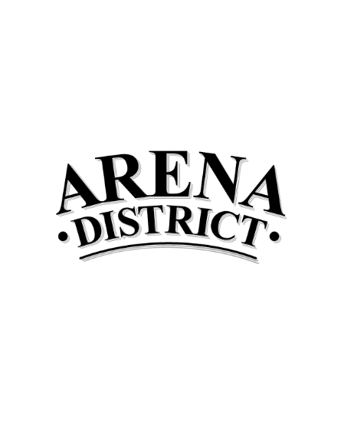
November 2018 Calendar of Events

Sunday | Monday | Tuesday | Wednesday | Thursday | Friday | Saturday
 |  |  |  | 1 | 2 | 3
 |  |  |  |  | EL = Good Charlotte North American Tour (indoor), 6:00p
4 | 5 | 6 | 7 | 8 | 9 | 10
 |  | NA = Blue Jackets vs. Dallas Stars, 7:00p | NA = Fleetwood Mac concert, 8:00p |  | GCCC = The OSBA 2018 Capital Conference and Tradeshow  Est Attend = 8,000 | GCCC = The OSBA 2018 Capital Conference and Tradeshow  Est Attend = 8,000  EL = Tenacious D (indoor), 7:00p  NA = Blue Jackets vs. New York Rangers, 7:00p
11 | 12 | 13 | 14 | 15 | 16 | 17
GCCC = The OSBA 2018 Capital Conference and Tradeshow  Est Attend = 8,000 | GCCC = The OSBA 2018 Capital Conference and Tradeshow  Est Attend = 8,000 | GCCC = The OSBA 2018 Capital Conference and Tradeshow  Est Attend = 8,000 | GCCC = The OSBA 2018 Capital Conference and Tradeshow  Est Attend = 8,000 | NA = Blue Jackets vs. Florida Panthers, 7:00p |  | AD = Girls on the Run 5K, 9a (Columbus Commons)  EL = Beartooth - The Disease Tour - Presented by 99.7 The Blitz (indoor), 6:30p
18 | 19 | 20 | 21 | 22 | 23 | 24
EL = O.A.R. - Just Like Paradise Tour (indoor), 7:00p |  |  |  |  | NA = Blue Jackets vs. Toronto Maple Leafs, 7:00p | AD = Hungry Turkey 5K/10K, 8:45a (Genoa Park)
25 | 26 | 27 | 28 | 29 | 30
 |  |  |  | NA = Blue Jackets vs. Minnesota Wild, 7:00p
NA = Nationwide Arena EL = EXPRESS LIVE! HR= Hyatt Regency GCCC = Greater Cols. Convention Center AD = Arena District HP = Huntington Park

CALENDARS ARE SUBJECT TO CHANGE. NOT FOR EXTERNAL DISTRIBUTION.

